New Product Submission Form
Please complete a separate form for each new product submission and e-mail completed form and supporting documents to: mfgdata@wolterskluwer.com

For additional info, go to https://www.wolterskluwer.com/en/solutions/medi-span/about/manufacturers-exchange

Please submit the following supporting documents for each new product:
- Package Label/package insert
- HDA
- FDA Approval Letter (NDA, ANDA, BLA)
- Note: All products must have at least one identifier (NDC, UPC or HRI) and one price type (WAC, DP or SWP.)
NDC Number
InnerPack NDC*** (if applicable)
HRI Number
UPC Number
GTIN-14 Number
Reference NDC (if applicable)
NDA/ANDA/BLA
Product Name
Rx or OTC
Package Size (ml, gm, each)
Dosage Form
Wholesale Acquisition Cost (WAC)
Direct Price (DP)
Manufacturer’s Suggested Wholesale Price (SWP)
1st Ship Date (Launch of New products)
Labeler/Manufacturer Name
Country of Origin (Required for all items)

***If the product package has an inner NDC different from the outer NDC, please provide the NDC number for both the inner package and the outer package.

Manufacturer Product Image Submission Guide

Wolters Kluwer Health, a major provider of computerized health-related content, collects and publishes Prescription and OTC drug images in our Drug Image Database. Pharmacists and healthcare providers rely upon visual verification of drug products to verify accuracy in medication dispensing and administration. Inclusion of your product images in our Drug Image Database is important to ensure patient safety.

We request your assistance to provide Wolters Kluwer Health with digital images of your drug products for inclusion in our Drug Image Database. Please send all image files as attachments to our manufacturer email address:
mfgdata@wolterskluwer.com
Manufacturers may also send product examples (placebo), OTC products, and product images to our corporate address:

Wolters Kluwer Health – Medi-Span
Drug Image Dept.
8425 Woodfield Crossing Blvd. Suite 490
Indianapolis, IN 46240

In order to achieve image consistency, we have established submission guidelines displayed below:

- Image resolution 72 ppi or greater
- Image formats should be high-quality JPEG or PSD
- Image background should be a solid, neutral gray (see example below)
- Tablets/capsules should be photographed in pairs, positioned to show as much imprint information as possible.
- Image file names should include the product NDC e.g. 00002-5621-01.jpg
- Packaged products should generally be positioned so that the pertinent identifying text is right side up in the frame. If the product is much taller than it is wide, the product may be placed sideways to allow for a larger final image.
- Lighting should be positioned such that any texture or embossing on the subject is visible, with glare and shadows from the subject kept to a minimum.
- Packaging attributes should be included when applicable. Photos should include both box and inner tube for creams/ointments; box and inner bottle for ophthalmic and otic drops; outer box and wrapped patch for topical patches; stock bottle with liquid poured into medicine cup for oral liquids.
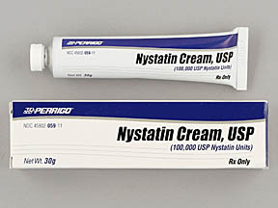
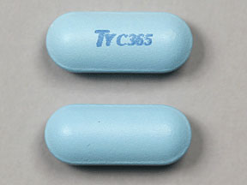
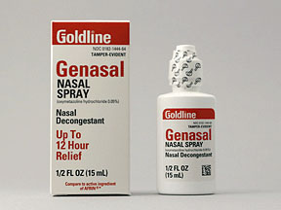
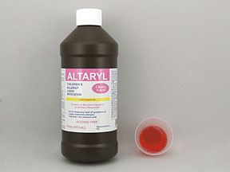
Image Examples

