Right click to place logo
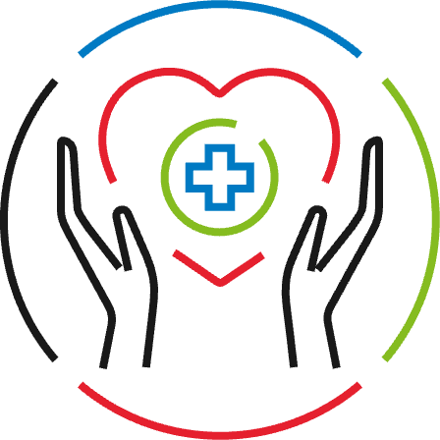

Help at Home:
After Being Discharged
from the Hospital
We want to ensure a safe transition home after you leave
the hospital. Your participation helps us confirm your needs
are being met. To monitor your health, we will check in with
you in the form of daily tasks, questions about your condition,
and more.
What to expect:

Friendly interactions, through phone calls, SMS texts, and emails.
Supporting information about transferring from hospital to home.
Questions about your recovery to help your care team understand your needs and progress as you transition home.
Privacy. We will not share your information with anyone other than you.

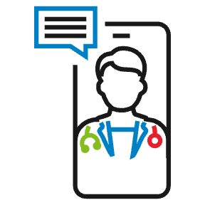
If you have any questions about your ongoing care needs, you may contact your doctor or us at
[HOSPITAL NAME HERE], (000) 000-0000.

Thank you for your participation.

If you have a serious problem,
call your doctor or 911. Help at Home calls cannot respond to problems or emergencies.

